### ****We Are With You Service – confidential advice and support about drinking****

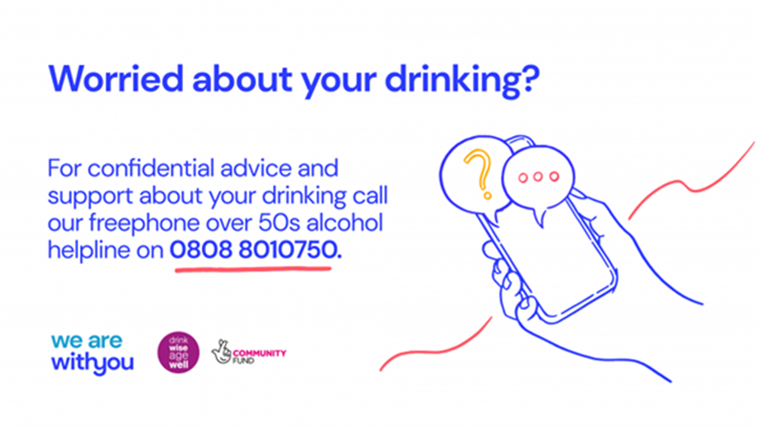

[With You](https://www.wearewithyou.org.uk/) has launched an [Over 50s Alcohol Helpline](https://www.wearewithyou.org.uk/help-and-advice/over-50s-alcohol-helpline/) which provides advice and support to individuals aged over 50, concerned others, and professionals, who are worried about their own or someone else’s drinking.

The [Over 50s Alcohol Helpline](https://www.wearewithyou.org.uk/help-and-advice/over-50s-alcohol-helpline/) now offers an enhanced service for individuals who are considering making changes to their alcohol use.  The enhanced service provision offers callers up to 4 additional appointments, during which time Helpline alcohol advisors use evidenced-based interventions to support callers to achieve their goals.

[More information](https://coronavirus.msehealthandcarepartnership.co.uk/localservicesandpathways/mental-health-services/alcohol-support-services/)